Project Proposal: Library Management System
Introduction
The Library Management System (LMS) is designed to automate and streamline the processes involved in managing a library. The system will consist of two primary user interfaces: the Admin Login Form and the Librarian Login Form. The admin interface will provide functionalities for managing librarians, while the librarian interface will handle book-related operations. The system will utilize three database tables: Librarian, Books, and IssueBooks.
Objectives
- Develop a user-friendly interface for administrators and librarians.
- Implement functionalities for adding, updating, and removing librarians and books.
- Facilitate the issuing and returning of books.
- Maintain accurate records of librarians, books, and book issues.
Functional Requirements
Admin Login Form
The admin login form allows an administrator to:
- Add Librarians:
  - Input fields: Name, Employee ID, Contact Information, Password.
  - Validate the input and save the librarian details in the Librarian table.
- Remove Librarians:
  - Select a librarian from a list or search by name/ID.
  - Confirm deletion and remove the librarian from the Librarian table.
- View Librarian Details:
  - Display a list of all librarians with details such as Name, Employee ID, and Contact Information.
  - Option to search and filter the list.
Librarian Login Form
The librarian login form allows a librarian to:
- Add Book Details:
  - Input fields: Book Title, Author, ISBN, Category, Number of Copies.
  - Validate the input and save the book details in the Books table.
- Remove Book Details:
  - Select a book from a list or search by title/ISBN.
  - Confirm deletion and remove the book from the Books table.
- Update Book Details:
  - Select a book to update from a list or search by title/ISBN.
  - Modify the book details and save the changes in the Books table.
- Issue Books to Students:
  - Input fields: Student ID, Book ID, Issue Date.
  - Validate the input and save the issue record in the IssueBooks table.
  - Update the number of available copies in the Books table.
- Record the Return of Books:
  - Input fields: Student ID, Book ID, Return Date.
  - Validate the input and update the issue record in the IssueBooks table.
  - Update the number of available copies in the Books table.
Database Schema
The system will use three tables:
- Librarian Table:
  - ID: Primary Key, Integer.
  - Name: Text.
  - email: VARCHAR
  - address: VARCHAR
  - Password: Text.
  - City varchar
  - Contact int
- Books Table:
  - Id; PK
  - Name varchar
  - Author: varchar
  - Call no: Unique, varchar
  - NumberOfCopies: Integer.
- IssueBooks Table:
  - ID: Primary Key, Integer.
  - StudentID: varchar
  - BookID: Integer.
  - IssueDate: Date.
Technology Stack
- Frontend: Java
- Database: MySQL
- Authentication: Session-based authentication for admin and librarian logins.
- Deployment: Web server (Apache) for hosting the application.
Implementation Plan
Phase 1: Requirements Gathering and Design
- Define detailed requirements.
- Create wireframes and UI designs for the admin and librarian interfaces.
- Design the database schema.
Phase 2: Development
- Set up the development environment.
- Implement the admin login form and functionalities.
- Implement the librarian login form and functionalities.
- Develop the backend APIs for interacting with the database.
- Integrate the frontend with backend APIs.
Phase 3: Testing
- Perform unit testing on individual modules.
- Conduct integration testing to ensure all components work together.
- Conduct user acceptance testing with a sample group of users.
Phase 4: Deployment
- Deploy the application on a web server.
- Perform final testing and debugging in the live environment.
- Provide training and documentation for users.
Phase 5: Maintenance and Support
- Monitor the system for issues.
- Provide regular updates and enhancements based on user feedback.
- Offer technical support for users.
Conclusion
The proposed Library Management System aims to enhance the efficiency and accuracy of library operations through a robust and user-friendly application. By automating key processes and maintaining comprehensive records, the LMS will significantly benefit administrators, librarians, and students.
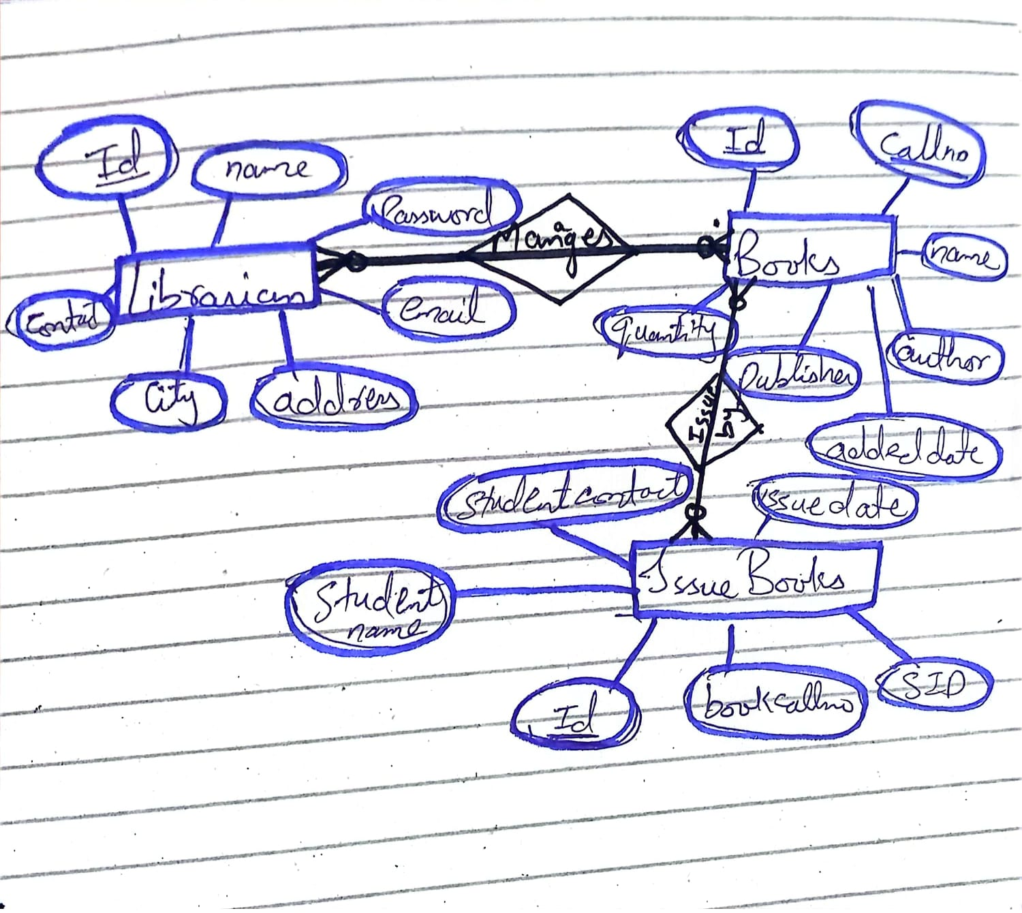
ERD

